Pulse: 0-1 Product Case Study

Context and background
The prompt we were handed was vague on purpose: "A mirror that tracks users' habits and notifies them." At first glance it reads awkward, but it actually surfaces three real design questions fast — what habit do we track, how does the user interact with it, and what do we do with that data to actually create value?
Those three questions became the spine of the whole project. We weren't building a gimmick. We were trying to figure out whether a mirror embedded in someone's environment could replace the friction-filled experience of going to the gym, opening an app, finding a plan, and actually following through. Spoiler: people quit workouts all the time, and it's rarely because they don't know what to do.

Your role & collaboration
I worked with two teammates — Jason W and Annalise. My role was less about doing one specific thing and more about keeping the quality bar high across everything. I spent most of my energy making sure my teammates had the context they needed to do their work well, giving feedback on deliverables before they went out, and making sure our research outputs were actually useful — not just technically complete.
I also did my share of the actual research: conducting interviews, moderating sessions, synthesizing data.

Timeline
The project ran nearly 2 months total — March 30 to May 11.
- Research planning — 1 week (defining scope, writing the research plan, aligning on methods)
- Expert interviews — 1 week (recruiting and conducting 3 expert sessions)
- Storyboarding + concept testing — 1 week (sketching concepts, running concept tests with 5 participants)
- Prototyping — 1 week (building the Pulse prototype)
- Usability testing — 1 week (running sessions, taking notes)
- Product-market fit — 1 week (competitive analysis, MVP definition)
- Analysis — 1 week (synthesizing findings across all research phases)
- Final synthesis + deliverables — 1 week (writing up outputs, preparing case study)

Research statement and goals
Where the problem came from: The prompt — "a mirror that tracks users' habits and notifies them" — was written by a classmate, voted on, and assigned by lot. Our team picked it. Before starting research we checked our interpretation with our instructor and got the green light to move forward.
Research statement: We want to better understand how busy students and professionals make decisions about at-home fitness and what keeps them consistent — in order to create a smart mirror companion that removes the friction between wanting to work out and actually doing it.
Research goals:
- Discover people's current decision-making around home workouts — when they do them, when they skip them, and how they feel about the overall experience of trying to stay consistent
- Learn about people's current pain points and barriers around existing fitness tools and routines — what frustrates them, what makes them quit, and what they wish was different
- Uncover the current tools people are using to stay active at home (apps, YouTube, wearables), their experience with those tools, and how they'd improve them
- Understand what consistency means to people in a fitness context — how they define it, why it matters to them, and what emotional role it plays in their daily life
- Evaluate how people interact with the Pulse prototype while performing a short workout — what works, what confuses them, and where the experience breaks down

Success Criteria
We defined success as: can a user start a workout within the first two minutes of interacting with the prototype without external help?
Secondary criteria:
- Users understand the AI coaching feedback without being coached on how to use it
- At least 3 out of 5 usability participants find the micro-workout flow intuitive
- No participant expresses confusion about what they're supposed to be doing mid-workout

Research methodology
We ran three methods back to back, each feeding into the next.
Expert Interviews — We talked to three domain experts to understand the problem before touching a prototype. One was a fitness instructor in Hangzhou specializing in personalized training programs. Another was a senior yoga instructor with years of front-line teaching experience. The third was Anatoly Volovik, a product advisor in health-tech. Each session ran about 30 minutes over video call. The goal was to hear from people who watch users fail at fitness every day — not just people who fail at it.
The big themes that came out: consistency is a relationship problem, not a knowledge problem. The return-after-quitting moment is the most dangerous design touchpoint because shame drives avoidance. Micro-workouts lower psychological barriers. Rigid schedules don't survive real life — people need flexible programs that adapt.
Concept Testing — After building lo-fi wireframes, we ran concept tests with 5 participants recruited from CCA campus. We presented three concepts: micro-workouts with calendar sync, an AI encouragement/facial tracking system, and AI posture coaching. The sessions were moderated by each team member across the 5 participants.
Usability Testing — We built a working prototype of Pulse and put it in front of real users. Participants stood up and did actual movements while we observed. Sessions ran about 30 minutes. We used a think-aloud protocol and followed a moderation guide with 3 defined tasks.

Recruitment criteria and process
Who we recruited:
- Age 18–35
- Full-time students or working professionals
- Living in dorms, studios, or shared spaces
- Self-identified as wanting to work out but struggling to stay consistent
Why: These are the exact people the product is built for — high intent, low follow-through. We needed people who've tried and fallen off, not people who already have an established gym habit.
How: We recruited mostly from CCA campus, leveraging existing networks. We also distributed a screener that got 22 responses, though converting those into actual scheduled sessions was harder than expected.
Incentive: None for this study — participants were volunteers.

Sample questions or usability tasks
Expert interview sample questions:
- What are your thoughts on busy individuals quitting home workouts because of time, motivation, or consistency issues?
- In your opinion, what's the best way to solve that problem?
- We're thinking about a smart mirror that uses your daily schedule and behavior to create a tailored workout plan. What do you think?
Usability test tasks:
- Task 1: Navigate the start of the Pulse app. What's your first impression?
- Task 2: Pick or edit your fitness profile.
- Task 3: Get started with a workout using the app — try the easiest one available.
Closing question (magic wand): If you could change anything about this experience, what would it be?

Analysis and synthesis process
After each usability session, we took notes during the session itself (one moderator, one note-taker where possible) and decompressed together afterward. We used a loose affinity-mapping process to group findings by theme across participants.
The themes that kept coming up:
- Text and visibility — almost every user said something was too small, too cluttered, or blocked by UI elements
- Gesture confusion — the pointing/pinching dual-gesture system was frustrating and inconsistent; users wanted one input method
- Onboarding friction — too many steps, no back button, no ability to skip minor inputs
- Workout clarity — users often didn't know what exercise they were doing, or what the rest screen even meant
- Customization overload — editing a workout plan felt overwhelming; users just wanted a curated workout fast

Outputs and deliverables
How might we — defined the problem space and scoped the project direction
How might we provide busy students and professionals with a personalized, low-friction fitness experience that eliminates the barriers of time and procrastination to help them build a lasting workout rhythm?
Crazy 8's
Research plan
3 personas
Expert interview summaries
Concept test report
Prototype mapping worksheet — mapped user journey phases to solution concepts
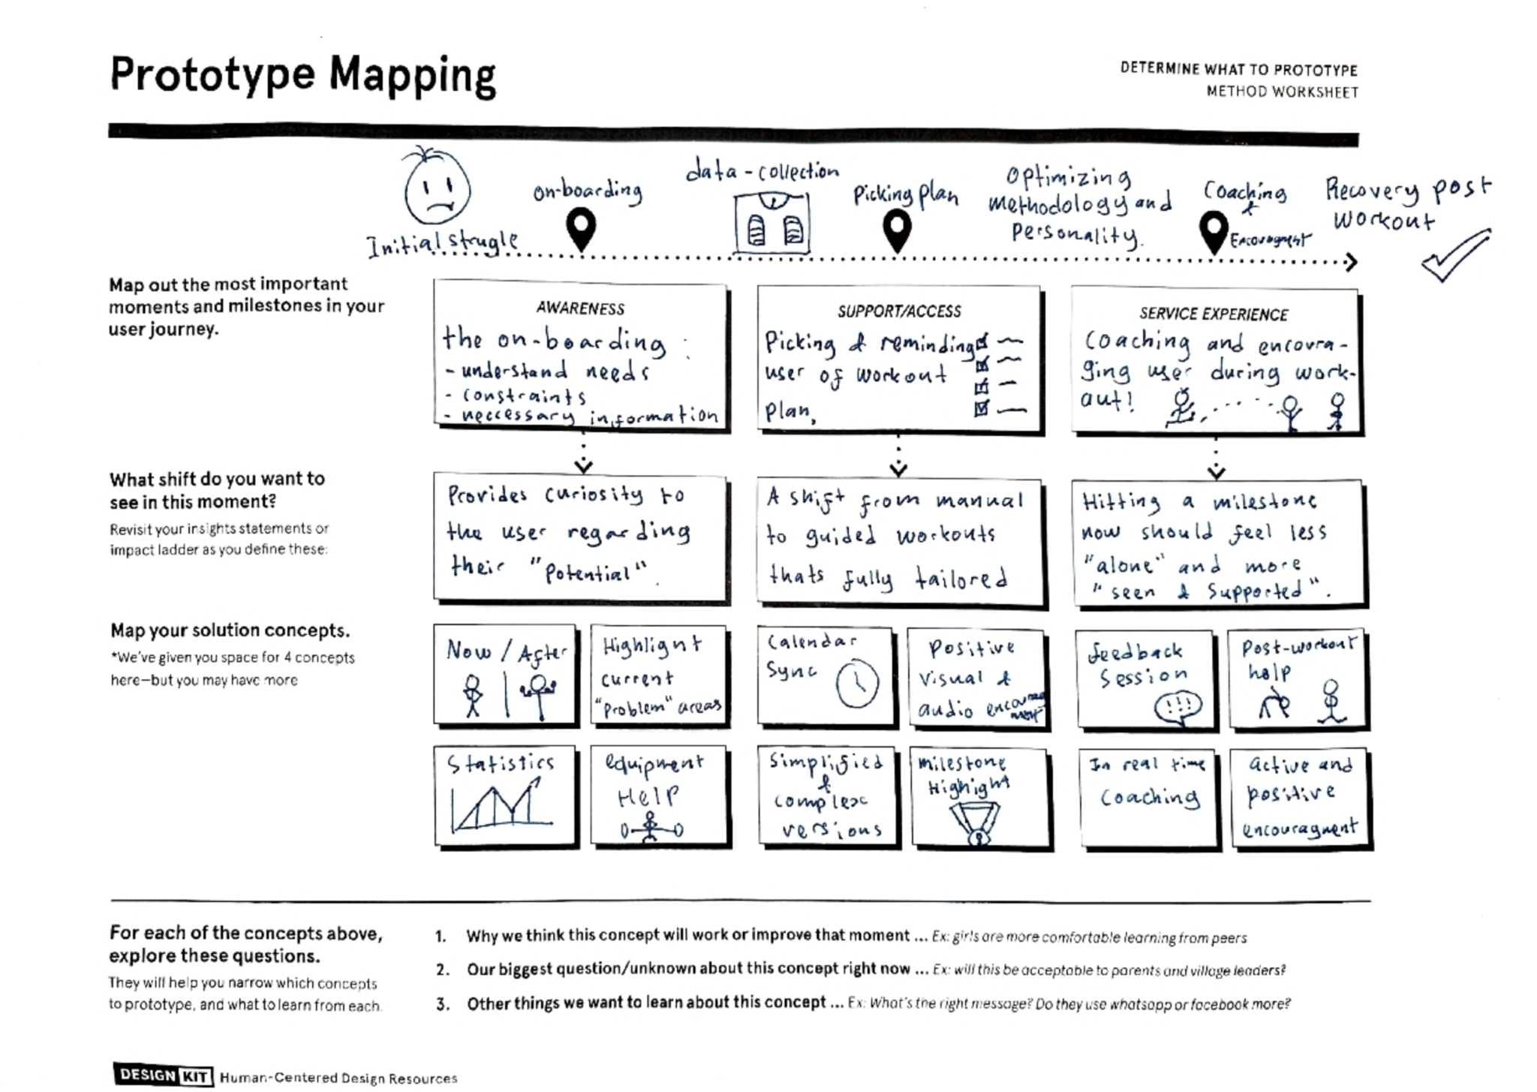
Prototype — Pulse
Usability test notes

Sharing and activation
Research was shared within the team as we went. After each round of research, we debriefed and updated our prototype direction. The expert interview insights fed directly into the concept test design. The concept test findings shaped the MVP definition. The usability test findings generated a prioritized list of fixes for the next iteration.
The prototype mapping worksheet was used as a shared artifact to align on what to build and why before we built it.

Impact
The biggest shift in the project came from the expert interviews, specifically from Anatoly Volovik. Going in, we were thinking about Pulse as a productivity tool — something that helps you squeeze a workout into a tight schedule. His insight that consistency is a relationship problem completely reframed the product. People don't quit because they don't have time. They quit because the product feels like a tool, not a companion. That one idea changed how we thought about every feature from that point forward.
Three concrete things changed because of the research:
- Facial expression tracking got cut — we had a concept where the mirror would read your expression to gauge if you were in the mood to work out. Concept testing killed it fast. Users found it creepy. Gone.
- Calendar-sync micro-workouts became the MVP core — not a nice-to-have, the actual entry point
- AI form correction stayed in — validated by both experts and concept testing as the highest-value feature
On the usability side, we came out with a clear redesign backlog: bigger text, single gesture modality, rest screen overhaul, prominent exercise name, and a simplified onboarding with a skip option.

Next steps and recommendations
Immediate fixes:
- Redesign rest screen with distinct color, large timer, and clear label
- Commit to pinch gesture only — remove pointing
- Add exercise name prominently (top or side) throughout workout
- Simplify onboarding to 2–3 steps max, add back button and skip option
- Show recommended workouts on the home screen by default; move customization into a profile section
Longer term:
- Build out the return-after-quitting flow — this is the highest-risk emotional moment
- Anchor the experience to an existing daily habit rather than asking users to build a new routine
- Explore wearable + mobile integration for tracking continuity outside the mirror

Reflections
What went well: The research process was solid. Moving expert interviews → concept testing → usability testing in sequence meant each round sharpened the next. The expert interviews especially gave us a strong conceptual foundation — Anatoly's reframe of consistency as a relationship problem was the kind of insight that changes how you look at everything downstream.
What didn't go well: The prototype. I was building it mostly alone since I had the laptop and the most experience with vibe-coding, and I genuinely underestimated how technically complicated it was going to get. The weird thing is that going deep on implementation made my UX brain kind of shut off. I missed things that should have been obvious to me — basic usability no-nos I would have caught immediately if I were evaluating someone else's work. Building and critiquing at the same time is harder than it sounds.
Recruiting was also a grind. 22 screener responses but converting those to actual scheduled sessions was slow.
What I'd change: Keep someone in the role of pure UX evaluator during prototype development — someone not building it, just poking holes in it. I needed that and didn't have it. I'd also push recruiting harder earlier so we're not scrambling at the end.

